23.69: a) 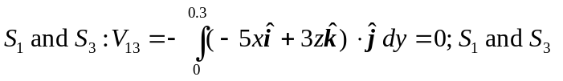 are at equal potentials.
b) 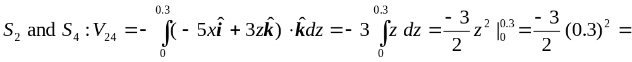
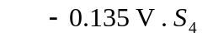is higher.
c)
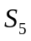 is higher.

